CRUD Operations using ASP.NET Web API and Angular.js
http://www.dotnetcurry.com/showarticle.aspx?ID=1049
Abstract: The AngularJS framework provides some cool features for developing MVC based applications using HTML. In this article, we will use AngularJS and ASP.NET Web API to create an application that pulls data from a database and performs CRUD Operations.
Download the entire source code of this article (Github)
AngularJS is one of the most popular client-side frameworks on the web. It is maintained by Google and helps in creating Single-Page Applications using HTML, CSS and JavaScript. This framework provides Model-View-Controller (MVC) on the client side and helps the developer to implement structural JavaScript on client-side. The Data-Binding and Dependency Injection features provided by Angular simplifies the heavy and complex JavaScript code on the client, which we used to write earlier to do the same task. If you are absolutely new to AngularJS, you can get some additional information over here.
In this article, we will make use of ASP.NET MVC WEB API and AngularJS to develop an application for performing CRUD operations. We will use the following features of AngularJS in our application:
DataBinding: This provides an automatic synchronization of data in between data model and the User interface components. This synchronization is managed in such a way that when any changes occur in either Model or View, it is notified to one another.
Module: Acts as a container for different components of the application e.g. Controller, Services, directives, etc. The bootstrapping of the application is specified by the Module. This is attached with DOM using ng-app directive.
Controller: Controller is a repository for the actions to be exposed to the DOM. This is a JavaScript constructor function attached to the DOM using ng-controller directive. When the controller is attached with DOM a new injectable scope parameter will be available to the controller’s constructor function of the name $scope.
Services: Component to act as a repository for the code to be shared across the application. Generally we can make use of it to define external services call from Angular application.

Some Angular Directives used in the Application
Directives add capability of extending HTML. They are the most complex and the most important part of AngularJS. Here are some built-in directives used in this application:
· ng-app: used to auto bootstrap the AngularJS application. This is typically applied to the root of HTML document e.g. <html>, <body>.
· ng-controller: used to attach the controller class to the view. This helps to expose the action methods and the scope model from the controller to be accessible to view.
· ng-model: used to bind the scope model declared in the controller to the UI elements e.g. input, select,etc.
· ng-repeat: used to instantiate the template for each item in the source collection received from the scope of the controller.
· ng-click: executes the action method form the controller class when the element on the View is clicked.
Read more about the various built-in Angular Directives over here.

The AngularJS & Web API Implementation
Step 1: Open Visual Studio 2013 (for this article VS2013 Ultimate with Update 3 is used) and create a new Empty MVC project. Name this project as ‘A6_Performing_CRUD_Using_Angular’.
Step 2: In the project, right-click on the App_Data folder and add a new Sql Server Database of the name ‘Application.mdf’. In this database add a new table with the name Employee having the following schema:
CREATE TABLE [dbo].[Employee] (
[EmpNo] INT IDENTITY (1, 1) NOT NULL,
[EmpName] VARCHAR (100) NOT NULL,
[Salary] INT NOT NULL,
[DeptName] VARCHAR (50) NOT NULL,
[Designation] VARCHAR (50) NOT NULL,
PRIMARY KEY CLUSTERED ([EmpNo] ASC)
);
Add some sample data to this table.
Step 3: In the Models folder, to create models, we need to add a new ADO.NET Entity Data model. Select the Application.mdf in the Entity Framework wizard and select Employee table. After completing the wizard, the table mapping will be as below:
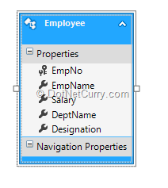
Step 4: We need to add the WEB API controller in MVC so that we can get methods for performing CRUD operations. Right-Click on the Controllers folder, add new Controller and select ‘WEB API 2 Controller with actions, using Entity Framework’ as shown here:
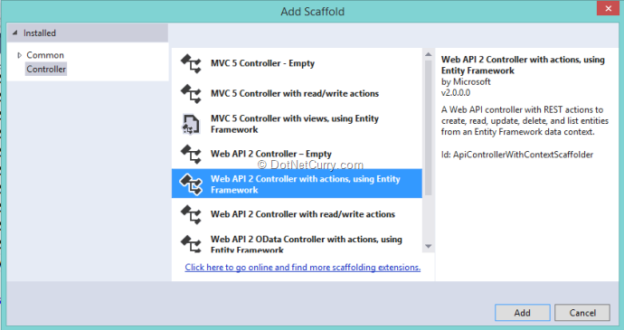
Step 5: Name the API controller as EmployeesAPIController. Set the Model class and Data Context class as shown here:
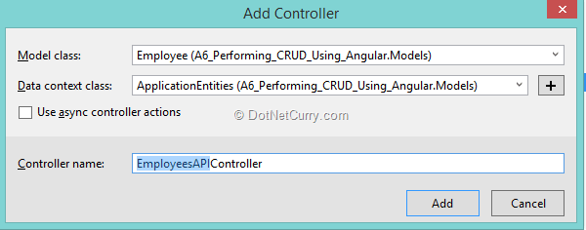
Step 6: Right-Click on the Controllers folder and add an Empty MVC controller of the name ‘EmployeeController’. This will add a controller with an Index action method in it. Scaffold the Empty View of name ‘Index.cshtml’ from the Index method.
Step 7: We need to add AngularJS to the current project. To do so, right-click on the project name and select ‘Manager NuGet Package’. From the Package Nuget Manager Window search for AngularJS as shown below and add it to the current project:
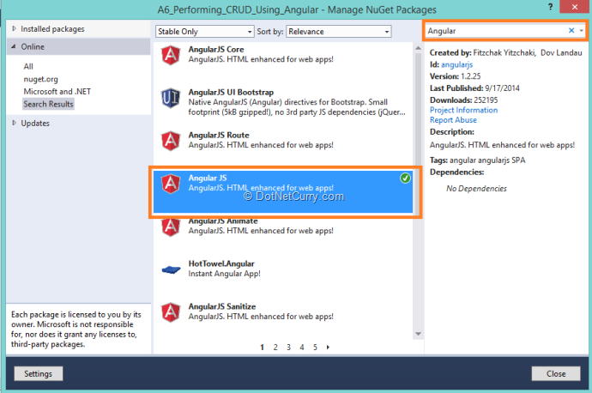
This will add Angular scripts in the scripts folder of the project.
Step 8: In the Scripts folder, add new folder and add 3 new JavaScript files in it. Name them Module.js, Service.js and Controller.js.
Module.js
/// <reference path="../angular.js" />
var app;
(function () {
app = angular.module("crudModule", []);
})();
The above code defines module of name ‘crudModule’. This will be used as Bootstrapper for the application and will be exposed to view using ng-app directive.
Service.js
/// <reference path="../angular.js" />
/// <reference path="Module.js" />

app.service('crudService', function ($http) {

//Create new record
this.post = function (Employee) {
var request = $http({
method: "post",
url: "/api/EmployeesAPI",
data: Employee
});
return request;
}
//Get Single Records
this.get = function (EmpNo) {
return $http.get("/api/EmployeesAPI/" + EmpNo);
}

//Get All Employees
this.getEmployees = function () {
return $http.get("/api/EmployeesAPI");
}

//Update the Record
this.put = function (EmpNo, Employee) {
var request = $http({
method: "put",
url: "/api/EmployeesAPI/" + EmpNo,
data: Employee
});
return request;
}
//Delete the Record
this.delete = function (EmpNo) {
var request = $http({
method: "delete",
url: "/api/EmployeesAPI/" + EmpNo
});
return request;
}
});
The above is the AngularJS service component with $http as dependency. This is used to make an external call to the WEB API using $http’s get, post, put and delete methods to perform CRUD operations.
$http is Angular’s wrapper around XmlHttpRequest. It provides a set of high level APIs and a low level API to talk to REST services. Each of the API methods return $q promise object. Following are the APIs exposed by $http:
- $http.$get(url): Sends an HTTP GET request to the URL specified
- $http.post(url, dataToBePosted): Sends an HTTP POST request to the URL specified
- $http.put(url, data): Sends an HTTP PUT request to the URL specified
- $http.patch(url, data): Sends an HTTP PATCH request to the URL specified
- $http.delete(url): Sends an HTTP DELETE request to the URL specified
Controller.js
It may include some additional details about $http. For example, you may say it is a wrapper around XmlHttpRequest object and brief about the shorthand methods it contains to perform HTTP operations.
/// <reference path="../angular.js" />

/// <reference path="Module.js" />

//The controller is having 'crudService' dependency.
//This controller makes call to methods from the service
app.controller('crudController', function ($scope, crudService) {

$scope.IsNewRecord = 1; //The flag for the new record

loadRecords();

//Function to load all Employee records
function loadRecords() {
var promiseGet = crudService.getEmployees(); //The MEthod Call from service

promiseGet.then(function (pl) { $scope.Employees = pl.data },
function (errorPl) {
$log.error('failure loading Employee', errorPl);
});
}

//The Save scope method use to define the Employee object.
//In this method if IsNewRecord is not zero then Update Employee else
//Create the Employee information to the server
$scope.save = function () {
var Employee = {
EmpNo: $scope.EmpNo,
EmpName: $scope.EmpName,
Salary: $scope.Salary,
DeptName: $scope.DeptName,
Designation: $scope.Designation
};
//If the flag is 1 the it si new record
if ($scope.IsNewRecord === 1) {
var promisePost = crudService.post(Employee);
promisePost.then(function (pl) {
$scope.EmpNo = pl.data.EmpNo;
loadRecords();
}, function (err) {
console.log("Err" + err);
});
} else { //Else Edit the record
var promisePut = crudService.put($scope.EmpNo,Employee);
promisePut.then(function (pl) {
$scope.Message = "Updated Successfuly";
loadRecords();
}, function (err) {
console.log("Err" + err);
});
}

};

//Method to Delete
$scope.delete = function () {
var promiseDelete = crudService.delete($scope.EmpNo);
promiseDelete.then(function (pl) {
$scope.Message = "Deleted Successfuly";
$scope.EmpNo = 0;
$scope.EmpName = "";
$scope.Salary = 0;
$scope.DeptName = "";
$scope.Designation = "";
loadRecords();
}, function (err) {
console.log("Err" + err);
});
}

//Method to Get Single Employee based on EmpNo
$scope.get = function (Emp) {
var promiseGetSingle = crudService.get(Emp.EmpNo);

promiseGetSingle.then(function (pl) {
var res = pl.data;
$scope.EmpNo = res.EmpNo;
$scope.EmpName = res.EmpName;
$scope.Salary = res.Salary;
$scope.DeptName = res.DeptName;
$scope.Designation = res.Designation;

$scope.IsNewRecord = 0;
},
function (errorPl) {
console.log('failure loading Employee', errorPl);
});
}
//Clear the Scopr models
$scope.clear = function () {
$scope.IsNewRecord = 1;
$scope.EmpNo = 0;
$scope.EmpName = "";
$scope.Salary = 0;
$scope.DeptName = "";
$scope.Designation = "";
}
});
The above controller has the $scope and crudService as its dependency. The $scope is used to define Models which will be exposed to View for DataBinding. The controller makes call to the service for performing CRUD operations. All these functions makes use of the ‘Promise’ object, which is used to monitor asynchronous progress. The promise will successfully return the data from the service when the function from service completes its call to external service. Following are the functions defined by the controller class:
· loadRecords - getEmployees() function of the service to read all employees.
· Save - This is the scope function used to Add/Edit record based upon the IsNewRecord flag.
· Delete - The scope function to delete the record.
· Get - The scope function to get Employee based upon the id.
· Clear - The scope function to clear all scope model declarations.
Step 9: Open the Index.cshtml, which we created in Step 6 and add the following Markup with DataBinding using AngularJs.
<html ng-app="crudModule">
@{
ViewBag.Title = "Index";
}

<head title="">
<style type="text/css">
#tblContainer, #tblcollections, #tblCRUD, td {
border: double;
}

th {
background-color: darkgray;
}

#dvcollection {
height: 500px;
overflow-y: scroll;
}
</style>

</head>
<h2>Using Angular for Performing CRUD Operations</h2>
<body>
<table id="tblContainer" ng-controller="crudController">
<tr>
<td>
<table id="tblCRUD">
<tr>
<td>
<span>EmpNo</span>
</td>
<td>
<input type="text" id="eno" readonly="readonly" ng-model="EmpNo"/>
</td>
</tr>
<tr>
<td>
<span>EmpName</span>
</td>
<td>
<input type="text" id="ename" required ng-model="EmpName" />
</td>
</tr>
<tr>
<td>
<span>Salary</span>
</td>
<td>
<input type="text" id="salary" required ng-model="Salary" />
</td>
</tr>
<tr>
<td>
<span>DeptName</span>
</td>
<td>
<input type="text" id="dname" required ng-model="DeptName" />
</td>
</tr>
<tr>
<td>
<span>Designation</span>
</td>
<td>
<input type="text" id="desig" required ng-model="Designation" />
</td>
</tr>
<tr>
<td>
<input type="button" id="new" value="New" ng-click="clear()" />
</td>
<td>
<input type="button" id="save" value="Save" ng-click="save()" />
</td>
<td>
<input type="button" id="delete" value="Delete" ng-click="delete()" />
</td>
</tr>
</table>
<div>{{Message}}</div>
</td>
<td>
<div id="dvcollection">
<table id="tblcollections">
<thead>
<tr>
<th>EmpNo</th>
<th>EmpName</th>
<th>Salary</th>
<th>DeptName</th>
<th>Designation</th>
</tr>
</thead>
<tbody ng-repeat="Emp in Employees">
<tr ng-click="get(Emp)">
<td> <span>{{Emp.EmpNo}}</span></td>
<td> <span>{{Emp.EmpName}}</span></td>
<td> <span>{{Emp.Salary}}</span></td>
<td> <span>{{Emp.DeptName}}</span></td>
<td> <span>{{Emp.Designation}}</span></td>
</tr>
</tbody>
</table>
</div>
</td>
</tr>
</table>
</body>
</html>

<script src="~/Scripts/angular.js"></script>
<script src="~/Scripts/angular-route.js"></script>
<script src="~/Scripts/MyScripts/Module.js"></script>
<script src="~/Scripts/MyScripts/Service.js"></script>
<script src="~/Scripts/MyScripts/Controller.js"></script>
The above HTML markup has the following features:
· The <html> is bound with the ‘crudModule’ using ng-app directive. This specifies that the Module with its contents e.g. Controller will be used in the bootstrap.
· The <table> with id ‘tblContainer’ is bound with the ‘crudController’ using ng-controller directive. This means that the declarations in the controller e.g. scope Models and functions will be available for the contents of the <table>.
· The <table> with id ‘tblCRUD’ contains <input> elements of the type ‘button’ and textboxes. Textboxes are bound with the scope models for Employee properties e.g. EmpNo, EmpName, Salary, DeptName and Designation using ng-Model directive. Buttons are bound with the functions from the controller using ng-click directive.
· The <table> with id as ‘tblCollections’ contains <tbody> which is bound with the Employees scope collection using ng-repeat directive. This iterates through the Employees collection and displays its contents in <span> elements inside the <td> elements using ‘{{}}’ bind syntax.
Run the application.
The page will appear as shown below:
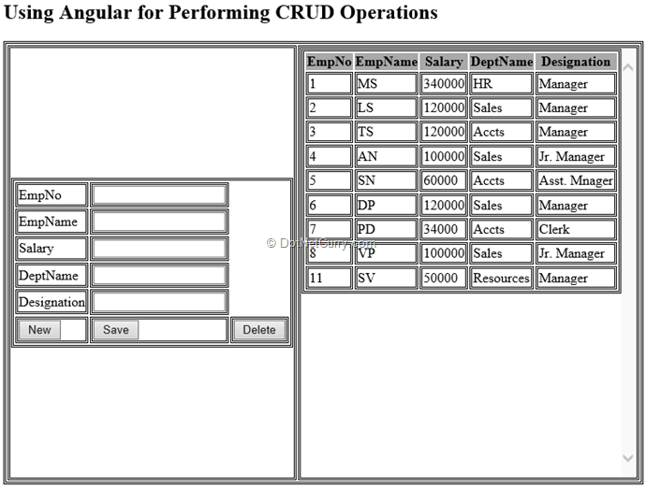
The above figure shows all Employee records in the Table.
Enter Data in the Textboxes except EmpNo and click on the ‘Save’ button. The data will be Saved, the EmpNo will be generated and displayed in the EmpNo Textbox and the Employee Table will be refreshed as shown here:
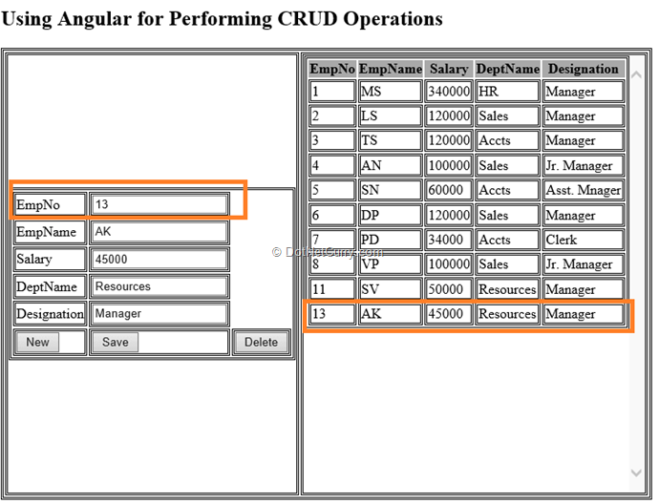
Click on the ‘New’ button which will clear all textboxes. Click on any row of the table and the selected record will be displayed in the Textboxes. Similarly Edit and Delete operations can be tested.
Conclusion: The AngularJS framework provides some cool features for developing MVC based applications using HTML. Modules, Controller and Services helps to implement a modular approach for application development on the client-side.

